DVC-4 Vibration Controller
VibrationWorld

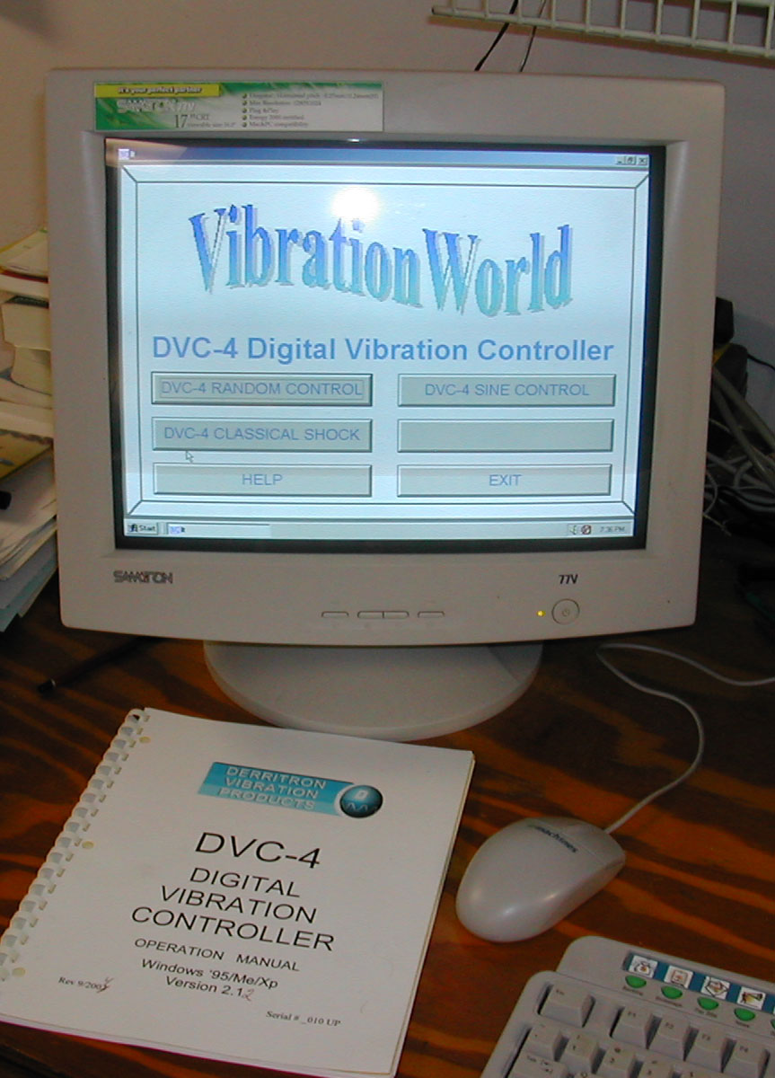

- Swept Sine

- Random

- Classical Shock
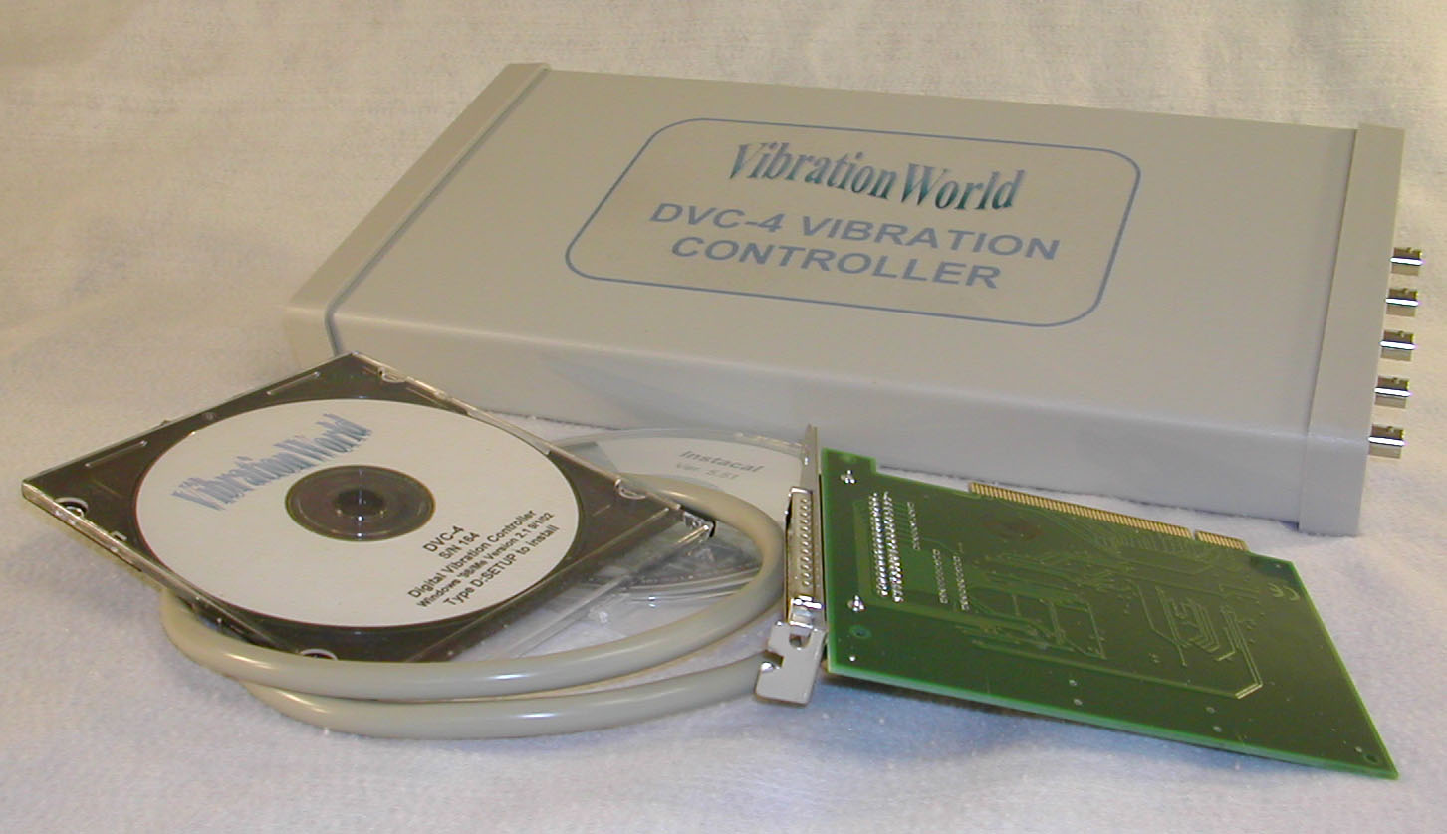

DVC-4 Features:

- Sine, Random, and/or Shock models.
- Established Reliability With 3-Year Warranty.
- Lifetime Free Software Upgrades and Demo Software.
- Use With Any Windows PC- Single PCI Slot Required.
- Easy to Install and Use- Ideal for Production Test and Small Systems.
- Virtual Instrument Screen with Familiar Windows Functions.
- 4 Input Channels with Current Sources standard.
- 8 Input Channel option with dual controllers.
- Remote Control via Hardware or Software.
- Software Calibration- no Trimpots; Calibration Procedure in Help File.

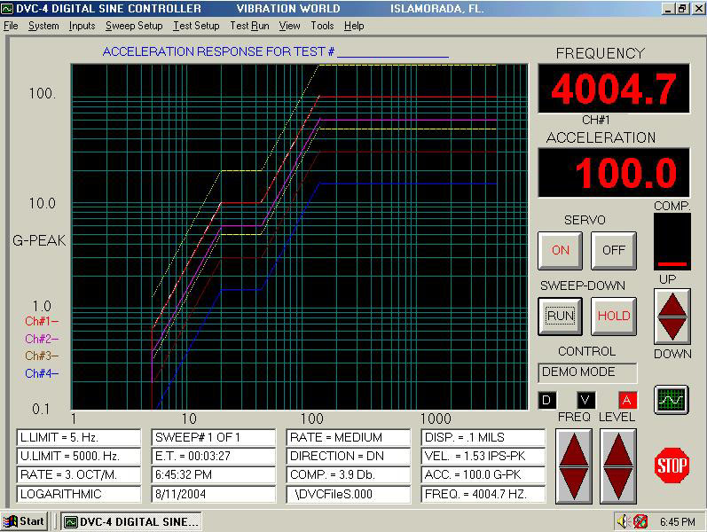

DVC-4 Vibration Control System For Sine, Random and Classical Shock testing

The DVC-4 Vibration Control System was one of the first controllers to take advantage of the Windows Operating System, combining DSP hardware with the Windows interface. This has resulted in a vibration controller with unparalleled economics and ease-of-use. The DVC-4 is fully compatible with Windows 98/Xp/ Vista and is available with any or all of the above control modes enabled.

Established Reliability

As the logical successor to the ISA slot DSC/DRC controllers, the DVC-4 has a ten-year history with DOS software and eight with Windows; over 1000 systems are in the field, and it is backed with a 3-year warranty.

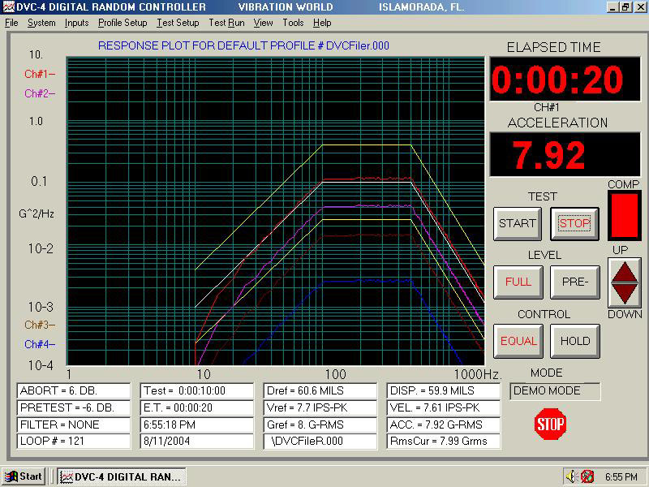

Built-In Accelerometer Current Sources

Simply connect the inputs to integrated accelerometers, turn on the current sources in the Inputs Menu, and run the test. The added expense and trouble of external charge-amps and power supplies are a thing of the past.

Virtual Instrument Screen

Your computer screen is turned into a “virtual instrument”, with plotting, LED style readouts, control buttons and status indicators all arranged in an easy-to-read format. All of the setup details are hidden in drop-down menus. Common functions can be performed by either mouse, keyboard, or hardware or software remote control. In addition, the monitor status bar provides the user a view of all test parameters for the current test.

4-Channel Input Standard
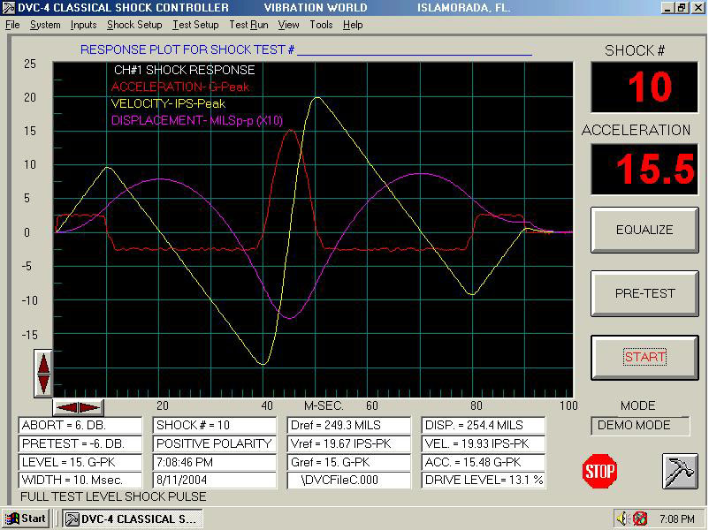
The sensitivity of each of the four input channels can be defined and a label may also be assigned along with a transducer serial number for future reference. The controller can be set to any combination of control or measurement channels.

Menu Setup

All of the details of the test setup are managed in familiar Windows drop-down menus; users will appreciate the familiar menu arrangement and quickly master entering test parameters.

Profile Setup

The Modify Profile screen defines the random PSD reference spectrum or sine D,V,A test schedule. Breakpoints can be defined in English or metric units and freely converted back and forth; up to 32 breakpoints can be defined for each test..

Free Software Upgrades

The software is typically updated twice/year and the upgrades are posted on the web-site for downloading- always for free. Combined with the extended warranty and no service contracts, the economical purchase price is the total cost except for a readily available computer.

Demo Software

Demo software is available on disk or on-line for training and product evaluation purposes; the working software can also be used in a demo mode for training purposes.

Use With Any Computer

Why be locked into an obsolete computer? Use the DVC-4 with any available PC and upgrade as technology moves foreword. The DVC-4 requires only one PCI card slot to interface with the control module. The software automatically resizes for use with any monitor. No ISA slots required!

Ease of Installation and Use

Operation of the DVC-4 controller can be mastered in minutes, without enduring the lengthy training period competitors require. The makes the DVC-4 well suited for production stress screening and small shops, where dedicated test labs and trained staff may not be present.

Remote Control

Common Start/Stop/Abort type functions can be controlled remotely by either logic signals or switch closures, or by software calls from another program to the DLL, enabling the DVC-4 to be integrated into test chambers and automated test systems.

Software Calibration

There are no trimpots or adjustments; calibration is done in software. The calibration procedure is included in the help file.

Manual Mode

All three software packages can be operated in a manual mode, simulating sine and shaped random signal generators, and waveform generator in shock.
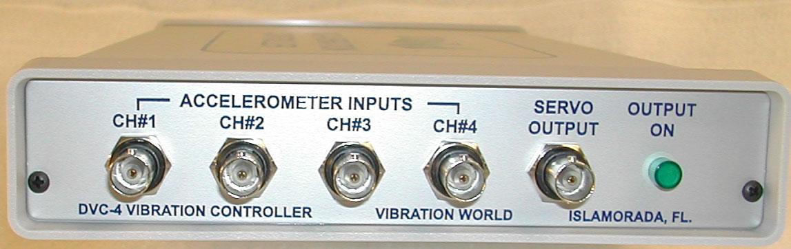

Software Package Specifications:

Sine Vibration Control Software Package DSC
Frequency : | Range: 2 Hz to 10 KHz.  Stability: +/= 100 ppm/° C, crystal controlled.  Distortion: <0.50% thd, 0.25% typical.  Limits: sweeps between programmed lower and upper limits.
Sweep Mode: | Linear, Logarithmic or MIL-167 Incremental.
Sweep Rate: | - Entered in Oct/min, Hz/sec, Hz/step  - 0.1-99.9 Oct/Min or 0.1-99.9 Hz/sec.
Control Method: | Average, Extremal, or Manual.
Control Channel: | Any combination of channels may be used for control and/or measurement.
Dynamic Range: | Greater than 70 dB.
Reference Profile: | - Defined with any combination of Displacement, Velocity or Acceleration.  - Up to 32 breakpoints may be defined.  - Automatic crossover frequency calculation from Displacement, Velocity or Acceleration.  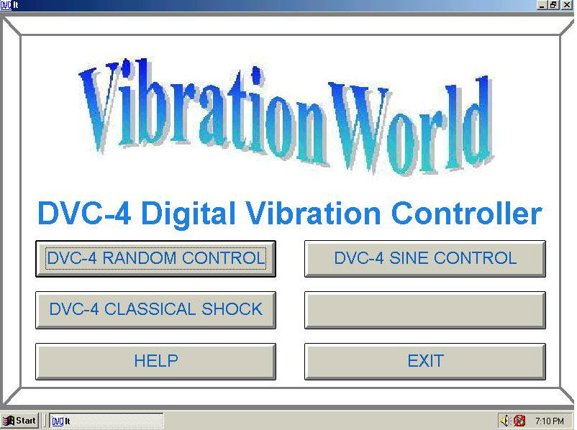  - Two dwells points can be programmed for a specified time at any desired frequency point.
Test Article Protection: | Automatic loop check for safety for open loop, low gain, over/under test and system limits.
Displays: | Interactive Windows displays, allowing for real time user display changes. Display types Include:  - Target Profile.  - Response of selected channel  - Alarm and abort limits.
Test Documentation: | Any of the above screens may be saved or printed out.
Display Monitor | The monitor bar displays the setup conditions, test status, and reference and current displacement, velocity and acceleration values.

Random Vibration Control Software Package DRC
Frequency Ranges: | 2.5-500, 5-1000, 10-2000, 20-4000 Hz.
Spectral Resolution: | 400 lines.
Control Method: | Average, Extremal, or Manual.
Control Channel: | Any combination of channels may be used for control and/or  measurement.
Dynamic Range: | Greater than 60 dB.
Loop Time: | 500 msec @ 2,000 Hz and 400 lines of resolution.
Equalization: | ±1 dB typical
Reference PSD:  (Profile) | - Defined by G²/Hz or m/s²/Hz with up to 50 breakpoints.  - Separate alarm/abort limits defined for each segment or overall setting.
Random Signal: | True random signal of gaussian amplitude distribution.
Sigma Clipping: | User selectable from 1.0 to 4.0 sigma.
Pre-test: | Settable from 1 to 20 Db below full test level.
Filtering | 8-pole anti-alias filters on all signal inputs and drive output..
Analysis Windowing | Rectangular, Hamming, Hanning or Blackman selectable.
Test Article Protection | Automatic loop check for safety for open loop, low gain, spectral or over/under test and system limits.
Displays: | Interactive Windows displays, allowing for real time user display changes. Completely zoomable plot. Display types Include:  - Reference spectrum  - Response spectrum for each channel or average of selected channels  - Transfer function of any channel, drive or test against any other channel  - Drive output  - Alarm/abort limits  - Captured waveforms for each input channel
Test Documentation | Any of the above screens may be saved or printed out.
Display Monitor | The monitor bar displays the setup conditions, test status, and reference and current displacement, velocity and acceleration values.
Classical Shock Control Software CSC
Waveform: | Pre-defined waveforms: half sine, initial/terminal peak Saw tooth, triangular, quarter-sine, parabolic cusp, sine-burst or custom user-generated waveform.
Pulse Width: | 0.1 to 100 msec for fixed waveform.
Analyzing Time: | 100 msec to 1 sec.
Sampling Frequency : | 1.28 KHz to 10.24 KHz
Equalization : | Low-level equalization on one channel ( Remaining channels available for measurement ).
Tolerance: | Alarm and abort, MIL 810, IEC + other standard limits.
Pulse Polarity: | ±, Selectable.
Pulse Modes: | Single or repetitive pulses, with settable pulse count and rep rate.
SRS Analysis: | Acceleration response with 400 line analysis.
Pre/Post- Compensation: | Automatic optimization of pre- and post- shock pulses or manual.
Parameters: | Acceleration, velocity & displacement in English or metric units.
Test Article Protection: | Automatic loop check for safety for open loop, low gain, over/under test and system limits.
Displays: | Interactive Windows displays, allowing for real time user display changes. Display types Include:  - Time Trace:  - Test Profile  - Accelerometer Response of any channel  - Acceleration, Velocity or Displacement plots  - Drive Waveform  - Alarm/Abort limits  - Shock Response Spectrum
Test Documentation: | Any of the above screens may be saved or printed out.
Display Monitor | The monitor bar displays the setup conditions, test status, and reference and current displacement, velocity and acceleration values.

Common Features
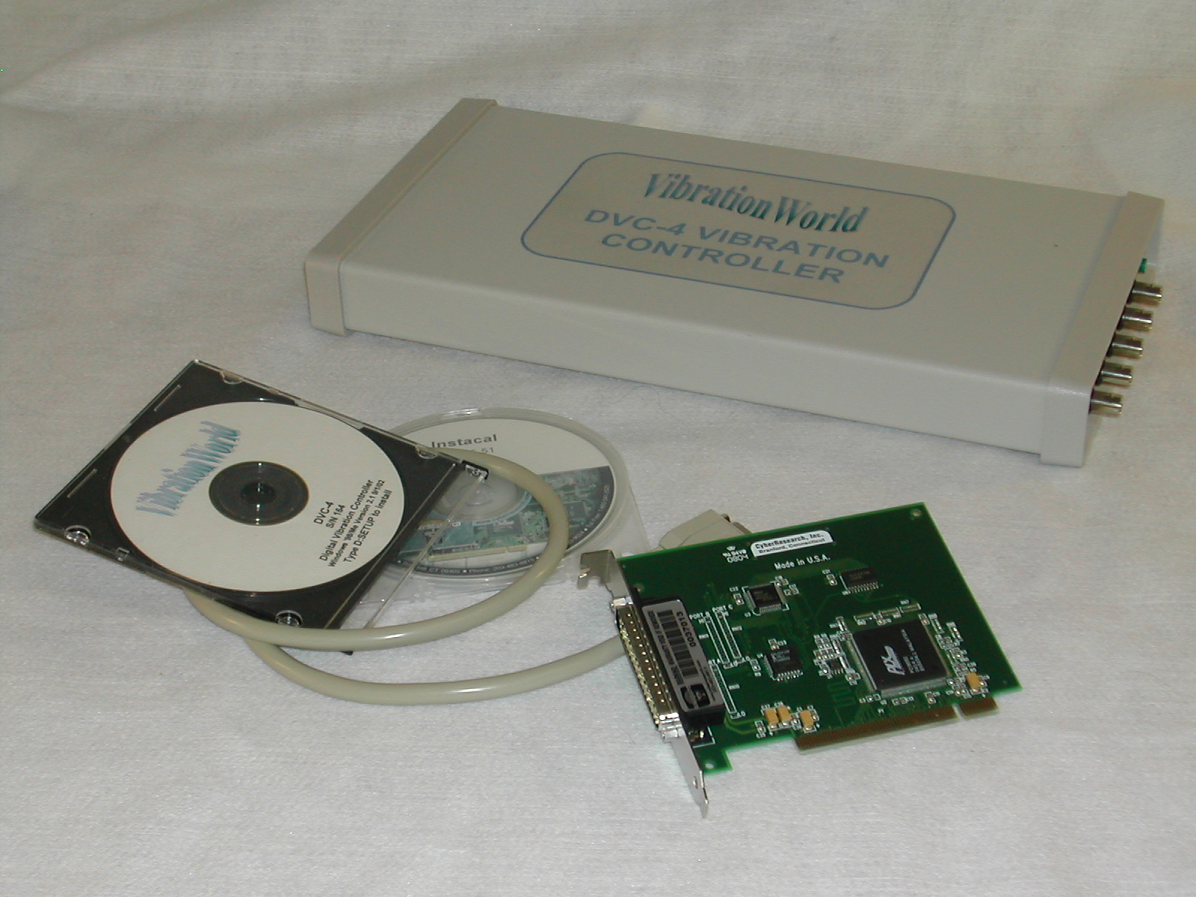
Input Channels: | 4 channel configuration standard
Input Sensitivity: | Settable from 5 to 1000 mv/g, 20 Vp-p maximum input each channel (BNC connectors).
Current Sources: | Four, 4 MA each input, 18 VDC compliance, software selectable.
Output Channels: | 1 Drive channel.
Output Level: | 16 Vp-p or 5 Vrms maximum (BNC connector).
Units | English or Metric with auto-conversion of all setup parameters.
Operating System: | Microsoft Windows 95/98/Me/NT/2000/Xp/Vista compatible.
Display: | Re-sizes automatically for all common screen resolutions.
Hard Copy | Any printer supported by the Windows Operating System; color or black & white printouts.
Remote Control: | Remote Start/Stop/Abort with external logic signal, switch closure, or by DLL calls for external software control.
Test Results  Export of Data  Calibration | Displayed or Auto-Save, Auto-Print or Auto-Export test results  Industry standard EXCEL file format or to clipboard.  Software calibration- no trimpots; calibration procedure in help file and manual
Computer Requirements: | 1 Ghz Pentium or better; uses 20 mb memory and 1 PCI card slot.
Size  Shipping Weight | 1.5”H x 7.25”W x 15”D  8 pounds

Revised 9/21/07

VibrationWorld by Wayne Pauly, Inc., 288 South Drive, Islamorada, Fl., 33036
Phone: (305) 664-8661, Fax: (305) 853-0568, Web: www.vibrationworld.com, E-mail: waynepauly@usa.net

Rev. 0/21/07

